**Unit 3**　**What Would You Like?**

**Part B** (**2**)

语句 应用练

1. 火眼金睛选一选。(20分)

(　　)1.Let________sweep the floor.

A．I　　　 B．my　　　 C．me

(　　)2.We________a good time yesterday(昨天)．

A．had B．has C．have

(　　)3.I like________and________.

A．eggs，milks　　 B．egg，milk C．eggs，milk

(　　)4.________you tomorrow.

A．Look B．See C．Watch

二、你会翻译吗？(20分)

(　　)1.随便吃。

A．Can I help you? B．Help you. C．Help yourself.

(　　)2.我会使用筷子。

A．I can wash chopsticks. B．I can use chopsticks. C．I can cut chopsticks.

(　　)3.让我试一试。

A．Let me try. B．Let you try. C．Let me show.

(　　)4.晚安。

A．Good morning. B．Good night. C．Goodbye.

情景 交际练

三、根据图片，选择合适的词完成句子。(注意大小写。)(60分)

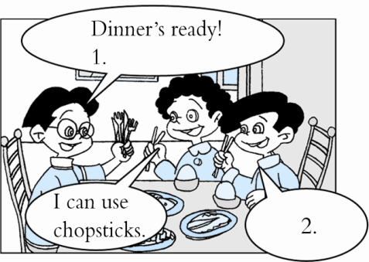

knives　 try　 help　 forks　 yourself

me too food Chinese show

1．Your and .

2． .

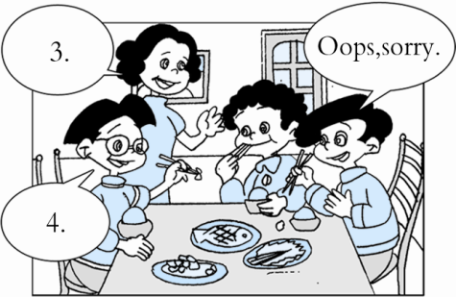

3. .

4．Let me you.

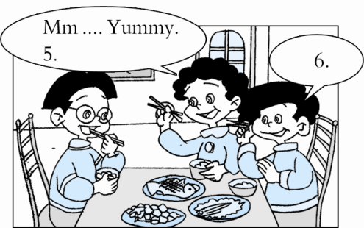

5．I like .

6．Me .

**答案全析全解**

一、1.C　2.A　3.C　4.B

二、1.C　2.B　3.A　4.B

三、1.forks；knives　　2.me；try 3．Help；yourself 4.show

5．Chinese；food 6.too